1. Find an alert (I went to <https://alerts.weather.gov/cap/us.php?x=1> in order to find one. Scroll down until you find an “Immediate”.)   
   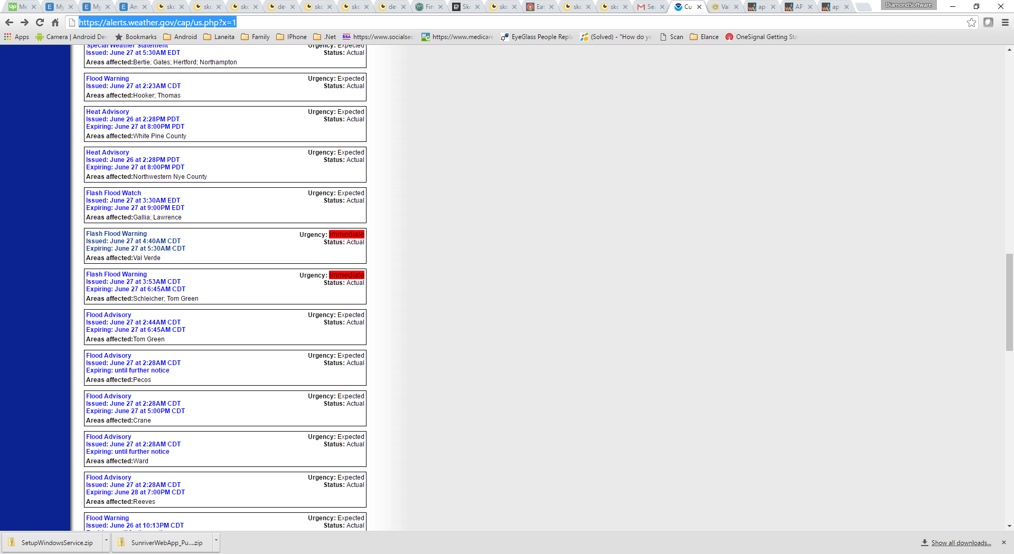
2. Find an associated zip and then:
3. Point your browser the the URL – like the one below.

<http://api.wunderground.com/api/bc2f8db95e1b5405/alerts/q/78837.json>

Sample results:

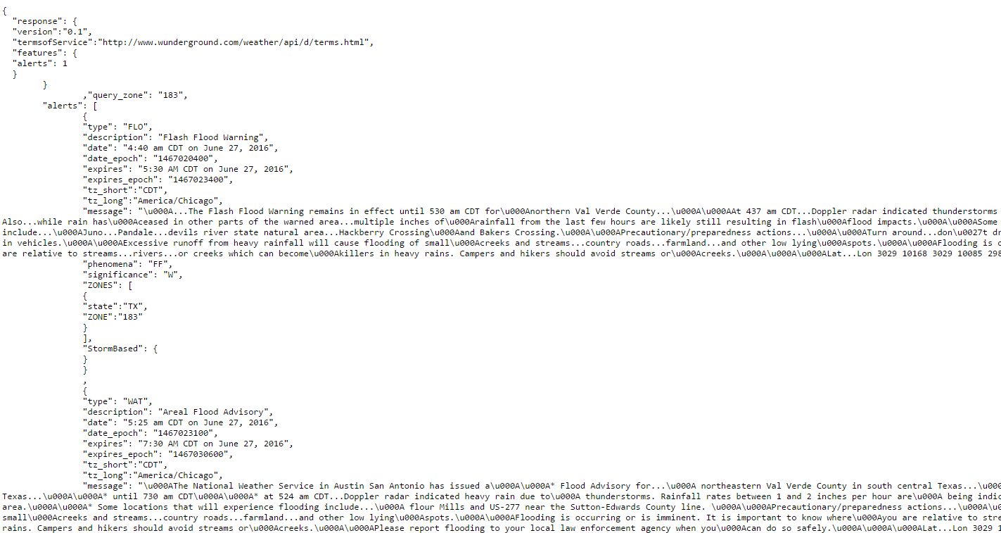

1. Uninstall existing service  
   Go to Add or Remove Programs. Do a Remove on the program is called SetupWindowsService  
   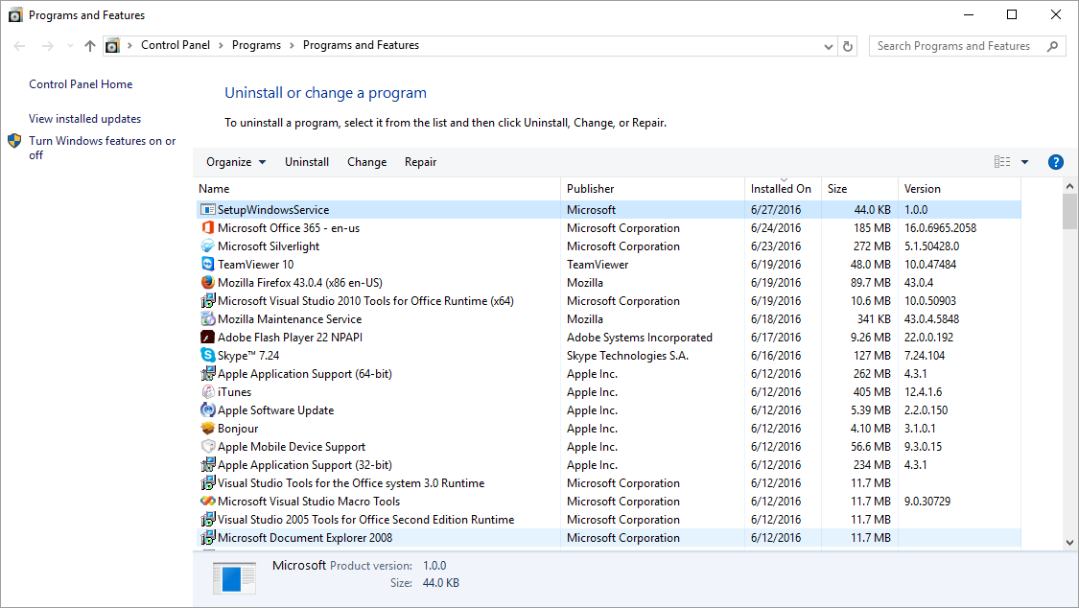  
     
     
     
   Then: Install the service by Double clicking the new .msi I sent you.  
   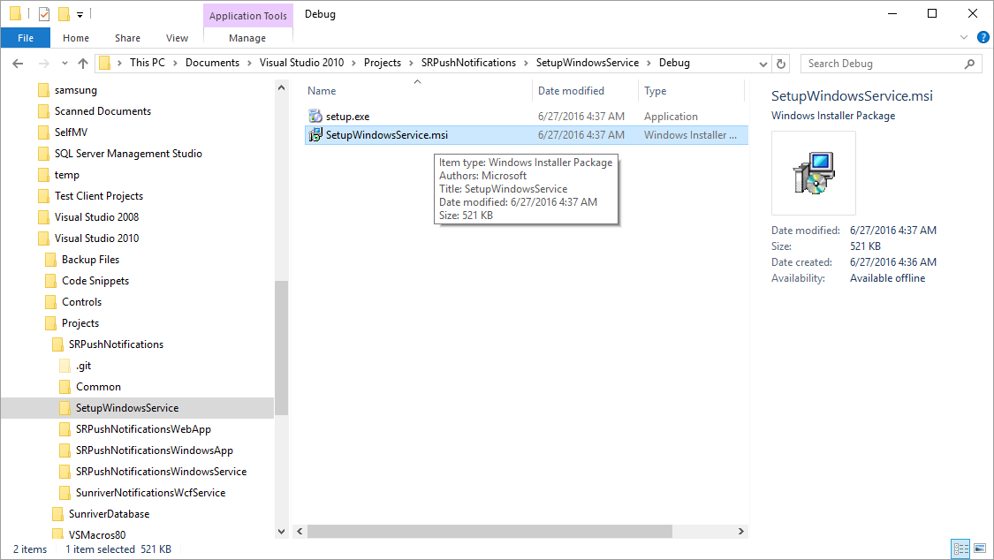  
     
   Click “Everyone”  
   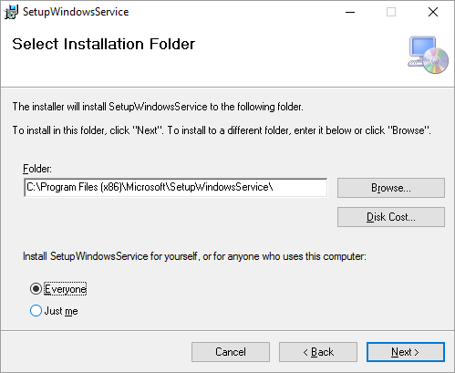
2. Change the settings in the config file  
   1. Stop the service
   2. Go to the config file and change the location of the web service, per the original instructions

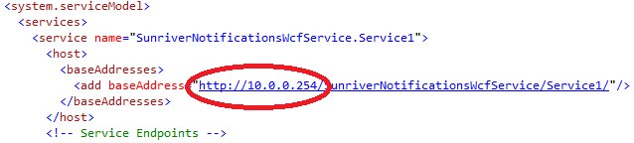

* 1. Start the service

1. Check your Event Viewer  
   You should see the following messages:  
   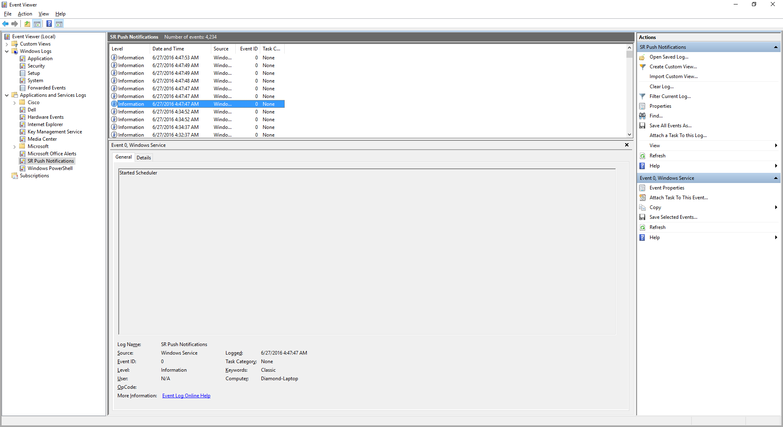  
   And then:  
   Weather alert timer popped  
   Trying URL: <http://api.wunderground.com/api/bc2f8db95e1b5405/alerts/q/78837.json>  
   And then:  
   Alert Found, or a No Alerts Found
2. If an alert was found, check your alerts table in the database. You should see an entry:  
   